## “A way of communicating from the human and spiritual dynamic”: third article by Fr. Gildasio Mendes in the series "St. Francis de Sales Communicator. Inner pilgrimage, wisdom in the art of communicating"

24 March 2022

[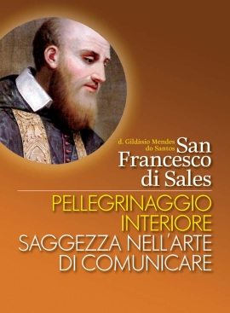](https://www.infoans.org/media/k2/items/cache/af00d3af9175d828bcc6a4bcd3204ad3_XL.jpg)

**A way of communicating from the human and spiritual dynamic**

Francis lived his communicative experience at various levels, through the different situations he experienced and decisions he had to take.

At one level Francis developed a style of communicating that was an expression of his spirituality, his loving image of God, his inner freedom to be honestly in touch with his own humanity and tendencies, his mystified fears with their anxieties, his dark nights and also the comfort he found in God's grace. It meant that he plumbed the depths of his humanity to find, in dialogue with God, the key and inspiration for his interpersonal communication. In his deep and true inner pilgrimage, he came to an authentic and honest confrontation with himself, and made choices that were priorities for his life.  For example, his inner tension between doing his father's will in his vocational choice and his deep desire to become a priest. Here we can identify the communicator who, in dialogue with himself, finds in God his inspiration and source for deciding on the basis of truth as the criterion.

At another level, in his interpersonal relationships Francis had an immense and wide network of people with whom he related and whom he accompanied. Francis expressed himself through dialogue and a great openness to understand the person starting from that individual’s circumstances, was open to what is different, without losing serenity, and acting confidently and charitably.

He was also a communicator in spiritual accompaniment, knowing how to follow the right dynamics of welcoming, listening, dialogue and deep understanding of the human person.  St Francis showed great human wisdom and psychological and spiritual maturity in his spiritual accompaniment of Jane-Frances de Chantal, in the way he understood the depths of the human individual. Jane-Frances de Chantal herself had this to say about it: “Francis was very generous in his spiritual direction, in accordance with the truth and variety of the authentic love he had for souls.”

At the level of community communication, Francis’ stance was one of a clear sense of reference: to his spiritual fatherliness, his moral authority and as the spiritual guide of his communities. Here we see a Francis de Sales growing in understanding of his institutional communication skills, maintaining openness, flexibility and firmness in confronting his adversaries.

At the same time Francis wisely managed the processes and decisions regarding institutional communication, especially as bishop, writing letters, documents, texts, defending the Church’s teaching when faced with a context of theological and ecclesial conflict, in his approach to Calvinist adversaries, and in the difficult decisions he had to take as bishop.

Therefore, at a personal, interpersonal and institutional level, Francis is revealed as a serene but firm communicator. He was gentle, yet determined, patient yet tenacious.